

Spring 2026

Name: Adil Khan
Roll no: 2610-4011
Department: BS AI

Lab no 4:

Style.css:
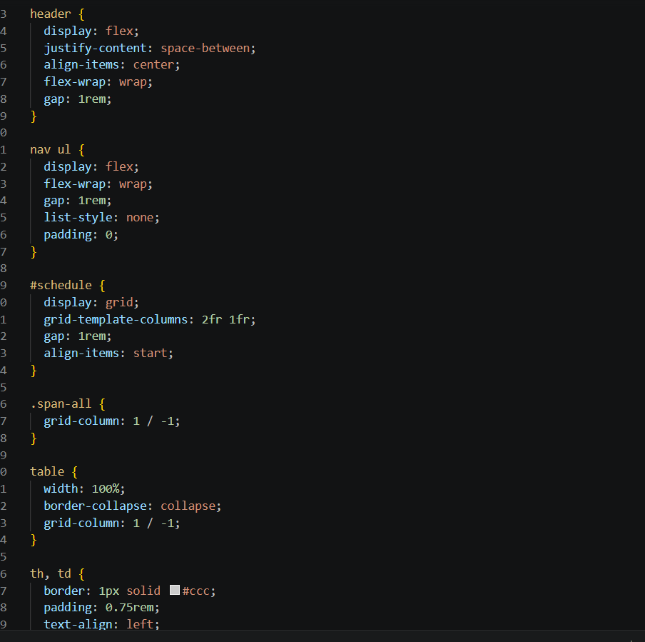

Index.html:
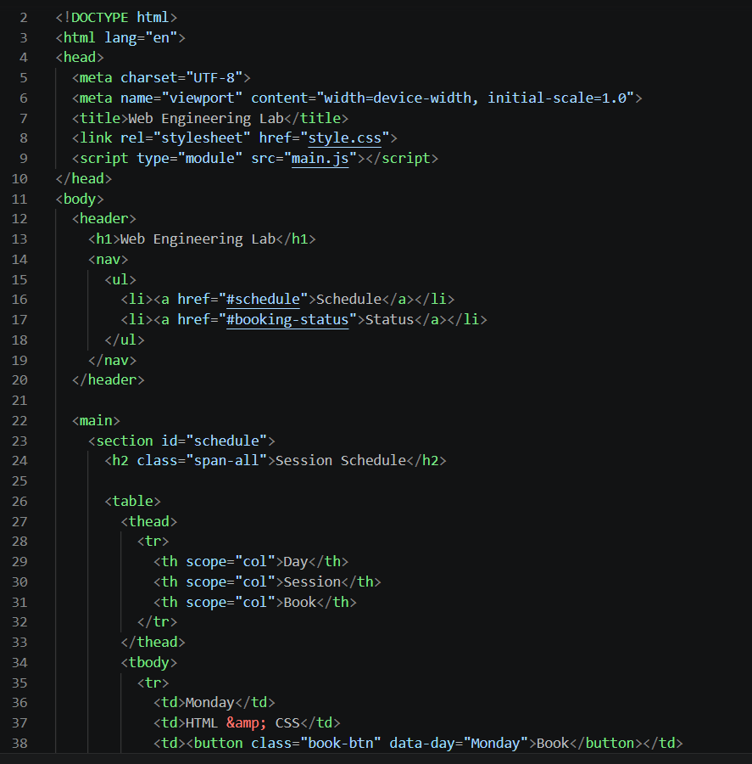

Main.js:

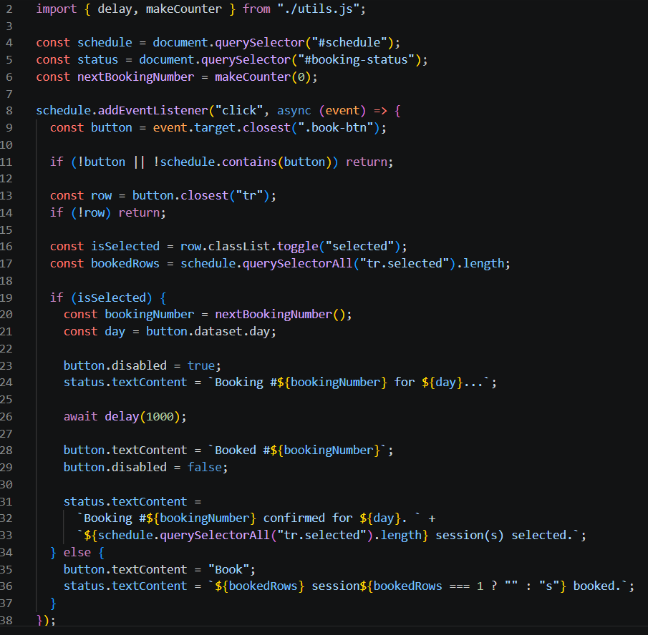

Utils.js:

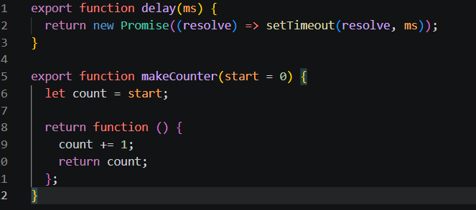

Output:
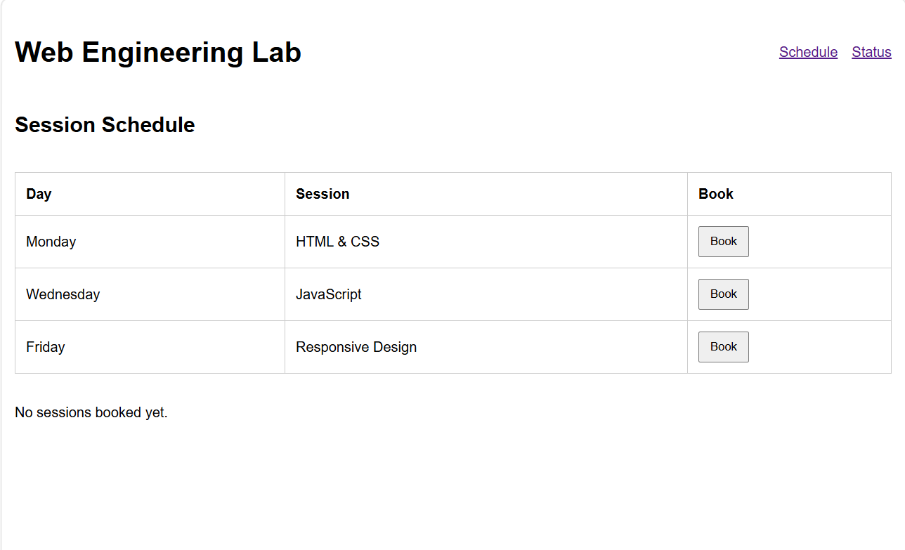

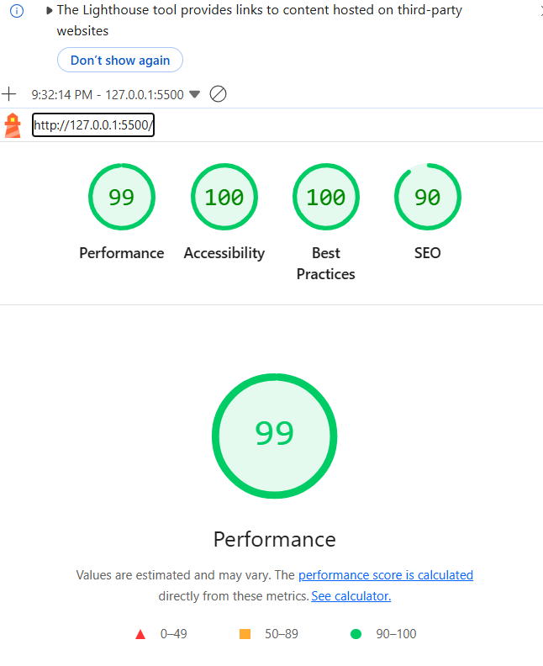

Github link
https://github.com/adil55yu/Web-Engineering

